**Supplementary materials for**

**CHAPTER 5**

**of**

***The Biology and Conservation of Animal Populations***

**by John A. Vucetich**

**Contents**

1. **Summary Points**
2. **Discussion Questions**
3. **Further Reading: elaborations**
4. **Further Reading: case studies**
5. **Practice Problems**
6. **Solutions to Practice Problems**
7. **Study guide**

An especially useful way to study and understand Chapter 5 is to consider the list of abilities you hope to gain from studying Chapter 5. Mastering Chapter 5 would mean being able to:

* Summarize the reasoning that leads to structured population dynamics. This reasoning was provided in *Conceptual Foundations* (p. 68). See pages 68-69. One way to acquire this ability is to work with a classmate. Each of you can prepare your own written summary. Write your summary, as if you are trying to teach your classmate the point of this section. Exchange summaries, and then discuss the strengths and weaknesses of your summaries.
* Convert a life cycle diagram into a projection matrix and vice versa. See pages 70-75.
* Perform matrix multiplication in Excel. See pages 75-78.
* Predict the abundance of a structured population many years into the future, using Excel, as you did while working with the practice problems.
* Perform sensitivity analysis in Excel, as you did while working with the practice problems.
* Summarize the specific findings of each case study in Chapter 5 (pages 82-93) and the general lesson that each case study illustrates. The specific findings of, for example, the Laysan albatross case are findings that apply only to that population. The general lesson of that case is whatever insight comes from that case, but is likely to apply to many other cases.

1. **Discussion questions**

* In Chapter 3 we learned that a population’s growth rate depends importantly on a population’s abundance and demographic stochasticity. In chapter 5 we learned that a population’s growth rate also depends on its age structure. What does that mean? How and why does growth also depend on age structure?
* In chapter 3 we focused on the per capita growth rate (r), but in chapter 5 we introduced λ. What is λ? How does λ compare with r? Why was λ introduced?
* What does it mean to perform a sensitivity analysis of a projection matrix? Set aside examples that were given in the chapter, and think about an animal population of conservation concern – a population that you think you know best. What are the most useful insights that could be ascertained about this population by performing sensitivity analysis?

1. **Further readings: elaborations**

* Page 72 of Chapter 5 stated:

The magnitude of the values associated with arrows circling back onto the same life stage may be interpreted as just described. But those values also reflect the duration of the stage. Larger values are indicative of a life stage for which an individual can spend more years. Knowing the details of that relationship are not necessary for gaining the key insights of this chapter.

You can launch your investigation of this topic by, e.g., seeing Section 2.3 and references therein of Varley and Boyce (2006).

Varley, N., & Boyce, M. S. (2006). [Adaptive management for reintroductions: updating a wolf recovery model for Yellowstone National Park](https://www.sciencedirect.com/science/article/pii/S0304380005004412?casa_token=rugoo7cYOnkAAAAA:tPK7r7nlydwi1sfDx6tOHKXRKM5T9n1PBpHxX7IoTcZDbdHHf9uNdNd371dILGLe3bIANeg). *Ecological Modelling*, *193*(3-4), 315-339.

* Pages 74-75 of Chapter 5 indicated that details of how the estimation of elements in a projection matrix can depend on when data are collected (throughout the course of a year and in relationship to the timing of reproduction). You can launch your investigation of this topic by, e.g., seeing section 3.1 and references therein of Gascoigne et al. 2023.

Gascoigne et al. (2023). [A standard protocol to report discrete stage‐structured demographic information](https://besjournals.onlinelibrary.wiley.com/doi/full/10.1111/2041-210X.14164). *Methods in Ecology and Evolution*, *14*(8), 2065-2083.

* Pages 78-79 of Chapter 5 made passing reference to stage-structured models that also take account of density dependence. You can launch your investigation of this topic by, e.g., seeing Section 2.2 of Varley and Boyce (2006).

**D. Further readings: case studies**

Below is an annotated list of cases where structured populations dynamics were used to gain insight about some population of conservation interest. Each case includes hyperlinks to further readings. Each case also provides guidance for how students can read these papers to develop their own summary of the case. The list can serve as the basis for a worthwhile class project.

1. LOGGERHEAD SEA TURTLES

The primary source for this case study is: Crowder, L. B., Crouse, D. T., Heppell, S. S., & Martin, T. H. (1994). [Predicting the impact of turtle excluder devices on loggerhead sea turtle populations](https://esajournals.onlinelibrary.wiley.com/doi/abs/10.2307/1941948). *Ecological applications*, *4*(3), 437-445.

A secondary source that provides useful context is: “[Turtle excluder devices: analysis of resistance to a successful conservation policy](https://www.southernfriedscience.com/turtle-excluder-devices-analysis-of-resistance-to-a-successful-conservation-policy/).”

You can be guided through these materials with this question, instruction, and tip:

Question: What is the problem being address in this case study?

Instruction: Provide a verbal description of the life cycle of the loggerhead sea turtles.

Draw a life cycle diagram for these turtles and translate that diagram into a projection matrix. (Hint: see Table 1 and the matrix at the bottom of p. 438.)

Tip: Crowder et al. (1994) has three basic results, pertaining to:

1. The use of elasticities to understand what vital rates are most important to loggerhead sea turtles. These results are represented by figures 1, 2 and 4.
2. An assessment of how turtle excluder devices (TEDs) could improve population trends for loggerhead sea turtles. These results are represented by Fig. 5.
3. An explanation of “transient dynamics,” which refers to how and why there is likely to be a temporary slow-down in the growth of the turtle population 20 to 30 years after the implementation of TEDs (see Fig. 6).

2. WILD BOARS SUPPORTED BY OCCASIONAL MAST PRODUCTION

The primary source material for this case study is: Bieber, C., & Ruf, T. (2005). [Population dynamics in wild boar Sus scrofa: ecology, elasticity of growth rate and implications for the management of pulsed resource consumers](https://besjournals.onlinelibrary.wiley.com/doi/full/10.1111/j.1365-2664.2005.01094.x). *Journal of Applied Ecology*, *42*(6), 1203-1213.

Here are some tips to help you read this paper:

* To understand the background for this case, as conveyed by the paper’s Introduction, aim to answer these questions:
  + What is the management concern?
  + What is the pertinent ecology, as it pertains to boars and mast production?
  + What was the authors’ initial insight, as it pertains to the value of analyzing projection matrices for different environmental condition?
* Describe, in your own words, the life cycle of wild boars and translate that description into a life cycle diagram and projection matrix.
* Describe, in your own words, the methods by which the authors estimated values used in the projection matrix.
* What are the authors’ main conclusions? What specific results support those conclusions?

3. CLIMATE CHANGE AND A MONTANE POPULATION OF FROGS

The primary source material for this case study is McCaffery, R. M., & Maxell, B. A. (2010). [Decreased winter severity increases viability of a montane frog population](https://www.pnas.org/content/pnas/107/19/8644.full.pdf). *Proceedings of the National Academy of Sciences*, *107*(19), 8644-8649.

Here are some tips for reading this paper:

* Based on the paper’s Introduction, what are the concerns pertaining to amphibian conservation and climate change?
* Describe, in your own words, the life cycle of the Columbia spotted frog and translate that description into a life cycle diagram and projection matrix.
* Describe, in your own words,
  + the field work upon which this study is based,
  + how the authors estimated the vital rates and the effect of climate on the vital rates,
  + how the researchers ran simulations and calculations to arrive at the paper’s conclusions.
* Hint: Notice the last two sentences on the first column of p. 8645. They begin: “Survival and transition probabilities…” This is a very important passage of text and is closely related to Fig. 3. This is key to understanding this part of the paper.

4. THE EFFECTS OF FOREST MANAGEMENT ON SALAMANDERS

The primary source material for this case study is: Homyack, J. A., & Haas, C. A. (2009). [Long-term effects of experimental forest harvesting on abundance and reproductive demography of terrestrial salamanders](https://doi.org/10.1016/j.biocon.2008.10.003). *Biological Conservation*, *142*(1), 110-121.

Here are some thoughts to guide your reading of this paper:

* It is important that forest management not unduly impact native fauna. Forest harvesting often results in dramatic reductions in the abundance of native salamanders. It’s not well known how long it takes for salamanders to recover. The authors use stage-structured modeling to help understand how long recovery is expected to take.
* Describe, in your own words, the life cycle of the studied salamander species and translate that description into a life cycle diagram and projection matrix.
* Describe, in your own words:
  + a description of the field work and empirical results,
  + how the authors estimated the values used in the projection matrix,
  + how the authors ran simulations and calculations to arrive at the paper’s conclusions.
* Explain how are the researchers’ conclusions are pertinent to the distinction between two broad approaches to conservation associated with the phrase, “land sharing and land sparing.” For context, see this easy-to-read [article](https://e360.yale.edu/features/sparing-vs-sharing-the-great-debate-over-how-to-protect-nature) on land sharing and sparing.

5. EXTINCTION RISK FOR THE DESERT TORTOISE IN THE WESTERN MOJAVE DESERT

The primary source material for this case study is: Doak, D., Kareiva, P., & Klepetka, B. (1994). [Modeling population viability for the desert tortoise in the western Mojave Desert](http://www.jstor.com/stable/1941949). *Ecological applications*, *4*(3), 446-460.

Here are some thoughts to help you read this paper:

1. What conservation challenge motivated this study? How is stage-structured modeling expected to help better understand the challenge?
2. Describe tortoise ecology, as it pertains to the influence of environmental stochasticity on population projections.
3. Describe, in your own words, the life cycle of the studied salamander species and translate that description into a life cycle diagram and projection matrix.
4. The 4th sentence of the abstract (“Importantly, simulations that include variation and correlation in vital rates…”) is very important. Let me help you understand it: The authors estimated vital rates in each of a number of years (1979-1989, see Table 1). The estimated vital rates differed among years, presumably due to environmental stochasticity (likely in the form of rainfall). The variability in these estimates is reported in Table 3. But there’s more. The vital rates did not vary independently from each other. Rather, the fluctuations in vital rates were correlated. That is, a “bad year” for survival was also likely to be a bad year for reproduction. And a “good year” was liable to be a good year for all of the vital rates. An important part of this paper (not the only important part) is to see how predictions of future tortoise abundance are affected by taking account of those correlations.
5. While the authors present many results in this paper, a core result might be readily conveyed by comparing two graphs. Perhaps the upper left and lower left panels of Fig. 5.

5. CLIMATE AND THE ASIATIC WILD ASS.

Finally, this paper is also readily accessible and conducive to being developed into a class assignment: Saltz, David, Daniel I. Rubenstein, and Gary C. White. 2006. [The impact of increased environmental stochasticity due to climate change on the dynamics of Asiatic wild ass](https://conbio.onlinelibrary.wiley.com/doi/abs/10.1111/j.1523-1739.2006.00486.x). Conservation Biology 20: 1402–1409.

**E. PRACTICE PROBLEMS**

1) Translate this life cycle diagram into a projection matrix:

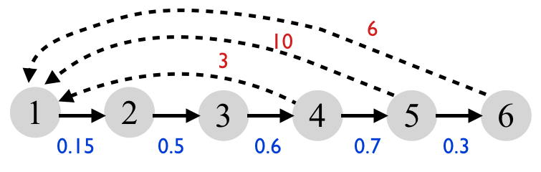

2) Translate this projection matrix into a life cycle diagram:

$$A=\left[\begin{matrix}0 & 0 & 0 & 5 \\ 0.1 & 0 & 0 & 0 \\ 0 & 0.3 & 0 & 0 \\ 0 & 0 & 0.6 & 0\end{matrix}\right]$$

3a) Perform the matrix multiplication shown below to predict population abundance in year *t*+1.

$$N\left(t+1\right)=\left[\begin{matrix}0 & 1.5 & 3.2 \\ 0.3 & 0 & 0 \\ 0 & 0.1 & 0\end{matrix}\right]∙\left[\begin{matrix}100 \\ 50 \\ 25\end{matrix}\right]$$

3b) From year *t* to *t*+1, what is the value of λ? (Report your answer to 3 places past the decimal point)

Note: If you feel that you need more practice with problems like (1) through (3), the instructor’s suggestion is that you make up a problem and then solve it. If you do so, your instructor would check your work.

4. LOGGERHEAD SEA TURTLES CASE EXAMPLE

4a) Translate this life cycle diagram for loggerhead sea turtles into a projection matrix:

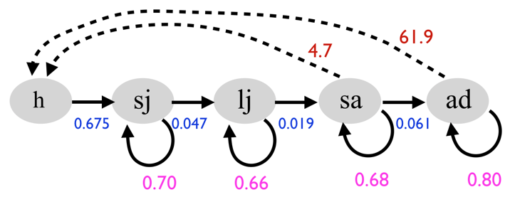The abbreviations are h = hatchlings, sj = small juveniles, lj = large juveniles, sa = subadults, ad = adults.

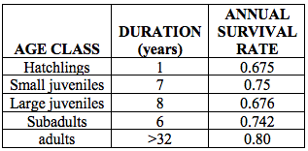

Information in the table to the right provides useful context about the life history and vital rates of loggerhead sea turtles. But you do not need that information to complete problem 4. If the relationship between this table and the life cycle diagram raises unanswered questions, feel free to ask.

4b) Suppose this population of sea turtles is described by the abundance vector below. What is next year’s abundance? (I recommend using Excel to make this calculation.)

$$N\left(0\right)=\left[\begin{matrix}2400 \\ 6500 \\ 1000 \\ 70 \\ 30\end{matrix}\right]$$

4c) What is the value of λ0? (Report you answer to 3 places past the decimal point.)

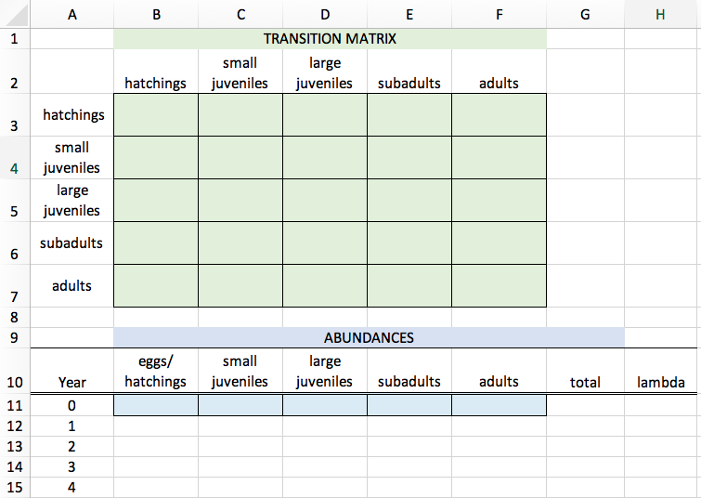4d) Project abundance for this sea turtle population over a 20-year period. To do so, set-up your Excel spreadsheet as shown here. Colored cells are places where you insert values. Other cells will be calculated with formulae.

When you calculate λ, report to three places past the decimal point.

4e) Make a graph of total abundance over time.

4f) Make a graph showing how λ changes over time.

Also, explore how changes in λ over time depend on the population’s initial age structure. In particular, make a graph showing how λ changes over time for each of these three starting conditions:

*scenario A scenario B scenario C:*

*(reduced hatchlings) (reduced adults) (increased adults)*

$N\left(0\right)= \left[\begin{matrix}100 \\ 6500 \\ 1000 \\ 70 \\ 30\end{matrix}\right]$ $N\left(0\right)=\left[\begin{matrix}2400 \\ 6500 \\ 1000 \\ 70 \\ 5\end{matrix}\right]$ $N\left(0\right)=\left[\begin{matrix}2400 \\ 6500 \\ 1000 \\ 70 \\ 50\end{matrix}\right]$

Notes:

* The graph for (4f) should have four lines, one for each of the three scenarios and another for the baseline condition, i.e., where ***N***(0) is set to the values shown in (4b).
* Set the range of the y-axis to [0.75, 1.10].
* When finished with this problem, reset the initial population size and age structure to that shown in (4b).

4g) This problem represents a simple sensitivity analysis to better understand how λ is more sensitive to changes in some vital rates than others. Create a bar chart showing how λ varies under three scenarios.

* Scenario A is the baseline scenario representing the projection matrix you provided in (4a).
* What is the reproductive rate of adults? Consider *Scenario B*, whereby adult reproductive rate is increased by 15%. For that scenario, what is the value of λ19?
* What is the annual survival rate of adults? Consider *Scenario C*, whereby adult survival is increased by 15% (to 0.924/year). For that scenario, what is the value of λ19?

Finally, by how much does adult reproductive rate have to be increased to observe λ19 = 1.0?

For context, Problem 4 is closely related to analyses performed in Crowder et al. (1994). Predicting the impact of turtle excluder devices on loggerhead sea turtle populations. *Ecological applications*, *4*(3), 437-445.

5. WILD BOARS IN EASTERN EUROPE

BACKGROUND: Across several parts of Europe, the abundance of wild boars has been increasing. The increase is a concern because boars can damage agricultural crops. Boars are also hunted for meat. And people sometimes make feeding stations for boars, as a way of diverting their attention away from crops.

These circumstances motivated two researchers from Vienna to analyze the structured dynamics for a population of wild boars living in Poland. The work you’ll do here is motivated by that research.

5a) Below is a useful projection matrix for the wild boar population. The first row represents juvenile boars, the second row represent yearling boars, and the third row represents adult boars. Draw the life cycle diagram for this population.

$$A= \left[\begin{matrix}0.26 & 0.94 & 1.93 \\ 0.33 & 0 & 0 \\ 0 & 0.40 & 0.66\end{matrix}\right]$$

5b) Project the abundance of this population over a 20-year period, supposing that the initial population size is:

$$N\left(0\right)=\left[\begin{matrix}63 \\ 19 \\ 18\end{matrix}\right]$$

Make a graph of total abundance over time.

5c) The number of hunters is limited, and managers would like to hunt in a manner that has the greatest impact on the population’s growth rate. Managers are considering three hunting scenarios; each would represent killing about the same number of individuals (at least during the early years of the harvest). Which scenario would have the greatest impact on the population’s growth rate?

Make a bar chart showing λ19 for each of the five scenarios:

*Scenario A*: baseline condition, as represented by the projection matrix in (5a).

*Scenario B*: adult boars are hunted; reduce their survival to 0.51/year.

*Scenario C*: yearling boars are hunted; reduce their survival to to 0.25/year.

*Scenario D*: juvenile boars are hunted; reduce their survival to 0.20/year.

*Scenario E*: Suppose that feeding stations can divert the attention of boars away from crops. But feeding stations also increase boars’ reproductive rates. Further suppose that complete removal of feeding stations would reduce reproductive rates of all age classes of boar by 25%.

What impact would each scenario (B through E) have on the population’s growth rate in relationship to the scenario A (baseline)?

The preceding analysis is related to this paper:  
Bieber & Ruf (2005). Population dynamics in wild boar, *Sus scrofa*: ecology, elasticity of growth rate and implications for the management of pulsed resource consumers. *Journal of Applied Ecology*, *42*(6), 1203-1213.

For more background on wild boars and the concerns they raise, see:

[Boar wars: how wild hogs are trashing European cities](https://www.theguardian.com/world/2019/jul/30/boar-wars-how-wild-hogs-are-trashing-european-cities?utm_source=ifttt)**.**

Write a short paragraph summarizing the findings of your analysis of wild boars.

**F. SOLUTIONS TO PRACTICE PROBLEMS**



$$A= \left[\begin{matrix}0 & 0 & 0 & 3 & 10 & 6 \\ 0.15 & 0 & 0 & 0 & 0 & 0 \\ 0 & 0.5 & 0 & 0 & 0 & 0 \\ 0 & 0 & 0.6 & 0 & 0 & 0 \\ 0 & 0 & 0 & 0.7 & 0 & 0 \\ 0 & 0 & 0 & 0 & 0.3 & 0\end{matrix}\right]$$

2)

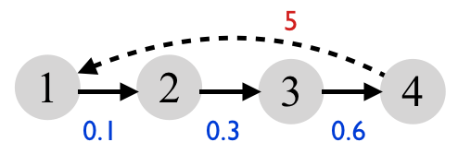

3a) $$N\left(t+1\right)=\left[\begin{matrix}0 & 1.5 & 3.2 \\ 0.3 & 0 & 0 \\ 0 & 0.1 & 0\end{matrix}\right]∙\left[\begin{matrix}100 \\ 50 \\ 25\end{matrix}\right]$$

$$N\left(t+1\right)=\left[\begin{matrix}\left(0×100\right)+\left(1.5×50\right)+(3.2×25) \\ \left(0.3×100\right)+\left(0×50\right)+(0×25) \\ \left(0×100\right)+\left(0.1×50\right)+(0×25)\end{matrix}\right]$$

$$N\left(t+1\right)=\left[\begin{matrix}155 \\ 30 \\ 5\end{matrix}\right]$$

Total abundance at time *t* was 175 (=100+50+25).

Total abundance at time *t*+1 is 190 (=155+30+5).

3b) λ = *Nt*+1/*Nt* = 190/175 = 1.086/year

4. Loggerhead sea turtles

Additional information on solutions to this problem may be found in the associated Excel file.

4a)

$$A= \left[\begin{matrix}0 & 0 & 0 & 4.7 & 61.9 \\ 0.675 & 0.70 & 0 & 0 & 0 \\ 0 & 0.047 & 0.66 & 0 & 0 \\ 0 & 0 & 0.019 & 0.68 & 0 \\ 0 & 0 & 0 & 0.061 & 0.80\end{matrix}\right]$$

4b) The number of sea turtles next year is:

$N\left(t+1\right)= \left[\begin{matrix}2186 \\ 6170 \\ 965.5 \\ 66.6 \\ 28.3\end{matrix}\right]$*Nt*+1 = 9,416 sea turtles

4c) λ = *Nt*+1/*Nt* = 10,000 / 9,412 = 0.942/year

4d) See Excel.

4e) The population is declining, asymptotically toward zero.

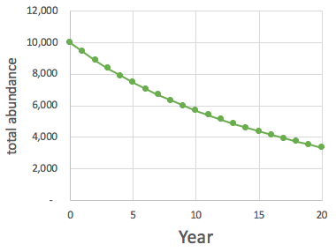

4f)

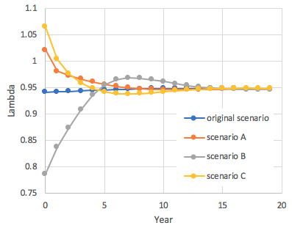

The starting value of λ depends strongly on the initial age structure. But as time passes, λ quickly converges to the same (equilibrium) value. That equilibrium value is entirely determined by ***A*** (the projection matrix).

4g) The reproductive rate of adults can be read off the projection matrix above. It is 61.9 hatchlings per adult per year.

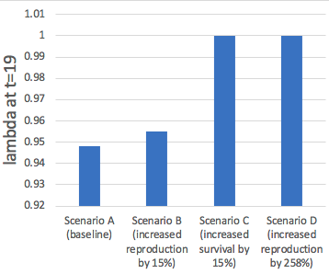

Increasing reproductive rate by 15% to 71.2 (=61.9 x 1.15) has the effect of increasing λ19 to 0.955/year.

The annual survival rate of adults can be read off the projection matrix above. It is 0.80/year. If you were to increase adult survival by 15% (to 0.924), then λ19 = 1.000.

The adult reproductive rate has to be increased to ~160 hatchlings/adult/year to realize λ19 = 1.000. That is 258% increase in reproductive rate.

5. Wild boars in eastern Europe

Additional information on solutions to this problem may be found in the associated Excel file.

5a)

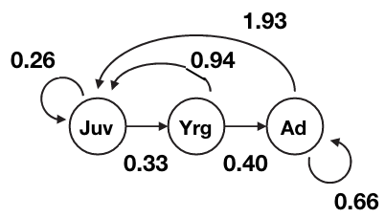

5b)

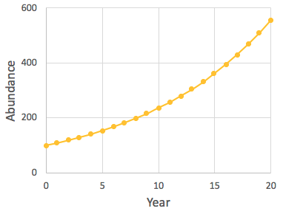

(5c)

