Sample Questions

Volume I: Wildlife Management Techniques: Research

Chapter 1: Design and Analytical Techniques
Edward O. Garton, Jon S. Horne, Jocelyn L. Aycrigg, and John T. Ratti

1. Describe a theory of wildlife science that you find particularly interesting by laying out its components in detail.
2. Tell how you would test such a theory by stating alternate predictions and resulting hypotheses or models that lead to specific data you would gather.
3. Design an experiment to test the theory.
4. How could you gather new observations to test the theory?
5. How would you build a model to test the theory?
6. How would you use the data resulting from your experiment, observations or model to test your theory?
7. If you were a manager in charge of a species to which your theory applied, how would you evaluate the theory during the course of your management program?
8. Understanding and conserving animals requires identifying a spatial population unit appropriate for study and management. Select a harvested species and a federally listed endangered species you find interesting and describe the spatial population units that you would focus on to meet the goal of insuring each species long-term sustainability and viability.

Chapter 2: Management and Analysis of Wildlife Biology Data
Bret A. Collier and Thomas W. Schwertner

- Field observations often lead to speculation on causal relationships between observed phenomena and ecological processes that may be used as the basis for developing and testing hypotheses. The results of this and other studies are then used to make broad statements concerning the system in question. Finally, these broad statements are applied to other components of the system (e.g., other species or other geographic areas) that haven’t been as intensively studies. Discuss where induction, deduction, and retroduction fit in this process. How might such things as sample design, data collection, and inherent population variability act at each stage to strengthen or weaken the process?

- From an article in a recent issue of The Journal of Wildlife Management, select a figure used to report the results of the study. What is the first attribute you notice about the figure? Does this attribute contribute or detract from the information being presented? After reading the article, does the figure present information that is not presented in the text of the article?

- In this chapter, we discuss methods of determining whether 2 variables are correlated? However, when analyzing correlation, it is important to keep in mind the phrase “correlation does not imply causation.” What is meant by this phrase? How does good experimental design address this concern?

- In what type of communities or studies might simple enumeration be an acceptable way of estimating species richness? Under what circumstances would it be a particularly poor method?

- Modern technological innovations such as statistical analysis packages and graphing software provide wildlife biologists powerful tools for collecting, analyzing, and presenting data. However, data collection, analysis, and presentation are based upon fundamental principles that are independent of the technology used. What are some of the advantages and disadvantages associated with using such tools in wildlife biology? How might these tools interfere with a biologist’s intuitive understanding of his analysis or detract from effective presentation of her results?

Chapter 3: Capture and Handling Techniques
Sanford D. Schemnitz, Gordon R.B batcheller, Matthew J. Lovallo, H. Bryant White, and Michael W. Fall

- Discus the pros and cons of using cannon nets versus rocket nets to capture wild animals.

- Describe the various ways that one can apply mist nets to capture wild animals.

- Describe the difference between bal-chatri, noose mats, and halo traps
- Discus the pros and cons of using box traps versus drop nets for the capture of wild animals.

- Foot traps, snares, and other forms of restraining traps can be divided into 2 broad categories–restraining (live) and killing traps. However, certain trap designs can be included in either category depending on how they are deployed in the field. Explain how these traps can be both restraining and killing under different deployment.

- Explain the difference between steel jaw traps and Foot encapsulating traps.

- Describe at least 3 methods to capture aquatic turtles.

Chapter 4: Wildlife Chemical Immobilization
Terry J. Kreeger

1. In order for non-veterinarians to legally administer prescription drugs to wildlife, they must establish what?
2. You need to immobilize a deer with ketamine and medetomine. The deer weighs 100 kg. You have ketamine at 100 mg/ml and medetomidine at 20 mg/ml concentrations. The doses for deer are 2 mg/kg ketamine plus 0.08 mg/kg medetomidine. How many mls of each do you need to immobilize the deer?
3. The deer is now safely immobilized. Name 3 things you should do initially before attaching a radio collar or take samples.
4. How can you best decrease stress of the animal during a capture operation?
5. The deer has stopped breathing. Name at least 3 different methods you could use to treat this condition.

Chapter 5: Use of Dogs in Wildlife Research and Management
David K. Dahlgren, R. DwayneEelmore, Deborah A. Smith, Aimee Hurt, Edward B.A arnett, and John W. Connelly

1. Various breeds of dogs possess traits that make them more or less suitable for select tasks. These traits vary between individual dogs within a breed as well. List traits that should be considered when evaluating a dog or breed for wildlife management.
2. Describe how traits or drives may differ between various working dog types (pointing dogs, hounds, herding, scat dogs). What attributes concerning the above traits and drives might you take into consideration for various projects? How might these drives affect training a dog for wildlife work? How might these various traits help you answer research objectives? Please give an example.
3. Pointing dogs have been found to be useful in locating birds such as quail, grouse, pheasants, and waterfowl. Other frequently used census techniques include walk and flush transects, call-counts, and nest dragging. List and compare these methods listing the pros and cons of each technique with particular attention to which circumstances one method might be preferable to another.
4. Write down a specific question or hypothesis you would like to address using dogs as a tool for sampling. What sampling bias factors need to be considered when using dogs to answer your question and how would they be quantified and factored into your analysis? Please recount the 5 standard procedures for reducing bias when using dogs in wildlife work.
5. Describe the full spectrum of strengths and limitations related to using dogs as a survey method for collection of wildlife data. What considerations are required before employing this technique? Are there particular situations (e.g. species, habitat) for which the use of dogs would be impractical or inappropriate?
6. Graph the current use of dogs as a data collection technique by taxa, habitat, and study objective. Where are there gaps in utilizing this methodology? Describe future applications, or variations of, using dogs in wildlife research and management that have not yet been explored. Provide detail on new species and study objectives for which this approach might be beneficial.
7. What specific part (e.g., section, reported technique, new piece of knowledge) of this chapter was most interesting to you? Describe why?
8. How is bird scent created? What environmental factors influence scenting conditions?

Chapter 6: Identifying and Handling Contaminant-Related Wildlife Mortality or Morbidity
Steven R. Sheffield, Joseph P. Sullivan, and Elwood F. Hill

1. Describe the differences in preparing a carcass for shipment to a diagnostic laboratory between an incident suspected of being caused by a contaminant, caused by a disease, or by a completely unknown cause.
2. Part A – Choose a class of chemical contaminants and describe the symptoms in live animals that would be indicative of that class of contaminants. Part B – Is it possible based on field observations to differentiate from impairment by other classes of chemical contaminants?
3. Part A – What are some methods that can be used to analyze contaminant exposure and possible effects on live wildlife species using non-lethal techniques? Part B – What are some methods that can be used to analyze contaminant exposure and possible effects using carcasses?
4. Part A – Which contaminants, or groups of contaminants, would you expect to bioaccumulate in tissues of wildlife species? Part B – If bioaccumulation was suspected in a wildlife population, exactly how could you test for this?
5. Part A - Once at an incident site, what data should be taken by the investigator? Part B – Following the initial visit, what decision process do you follow to determine the next steps?
6. At a site where wildlife mortality and/or morbidity were discovered and contaminants were suspected, what are the different environmental media that can be analyzed for contaminants, and how would sample collection, storage, and handling differ for each?

Chapter 7: Wildlife Health and Disease: Surveillance, Investigation, and Management
Markus J. Peterson and Pamela J. Ferro

- From an historical perspective, why are wildlife ecologists and managers often poorly equipped to participate in disease surveillance and management in free-roaming wildlife populations?

- Why is it critical that wildlife biologists become familiar with wildlife diseases and wildlife disease investigations?

- List and briefly describe the key aspects of a wildlife disease investigation.

- List the reasons why employers who expect wildlife biologists to conduct necropsies should provide expert training in necropsy procedures.

- List the 3 primary classes of management objectives relative to wildlife diseases. Which of these 3 objectives is most applicable to wildlife populations? Why?

Chapter 8: Criteria for Determining Sex and Age of Birds and Mammals
Eddie K. Lyons, Michael A. Schroeder, and Leslie A. Robb

- Discuss the pros and cons of using the tooth eruption criteria for classifying age categories in white-tailed deer.

- Describe the best techniques for determining accurate estimation of age and sex in birds and mammals. In reality, what has driven the development of particular techniques?

- Define the Bursa of Fabricius and describe its usefulness in determining age class in birds.

- Explain the use of the innominate bone, tuberosities, and ilio-pectineal eminences to identify sex and age of white-tailed deer.

- Diagram a bird wing and label the primaries, secondaries, greater coverts, middle coverts, lesser coverts, alula, primary coverts, and number both the secondaries and the primaries.

Chapter 9: Techniques for Marking Wildlife
Nova J. Silvy, Roel R. Lopez, and Markus J. Peterson

- Before attempting to mark free-ranging wildlife, a checklist of species and situation-dependent questions should be considered. What are these considerations?
- What appropriate approvals have to be obtained prior to trapping and marking wild animals? Endangered species?
- Discus the pros and cons of using natural marks versus capturing and marking wild animals.

- Discus the difference between non-invasive and invasive marks for use on wild animals.

- Most marking techniques are not permanent (i.e., last for the life of the animal), which marking techniques are considered to be most permanent for marking wild animals?

Chapter 10: Wildlife Radiotelemetry and Remote Monitoring
Joshua J. Millspaugh, Dylan C. Kesler, Roland W. Kays, Robert A. Gitzen, John HSschulz, Christopher T. Rota, Catherine M. Bodinof, Jerrold L. Belant, and Barbara J. Keller

1. Assume you are studying the effects of recreational activity on elk (Cervus elaphus) space use in the Black Hills, South Dakota. Identify 5 issues associated with study design that should be considered before collecting data. For each, briefly discuss how you should address.
2. What are steps you can take to reduce the possibility a transmitter affects normal activity patterns of an animal?
3. What options do you have for placing a transmitter on or in a salamander, such as an eastern hellbender (Cryptobranchus alleganiensis)? What factors would you consider in making such a decision?
4. You are researching the effects of prescribed fire on resource selection of black-backed woodpeckers (Picoides arcticus) in western Montana. These birds are medium-sized and weigh about 70 g. You expect these birds could move as far as 3 km during normal daily activities. Should suitable habitat become available, they could disperse 10’s of kilometers. Describe an optimal tracking system for these birds.
5. List the trade-offs between global positioning systems (GPS) and platform terminal transmitters (PTT) tracking systems?

Chapter 11: Estimating Animal Abundance
Brian L. Pierce, Roel R. Lopez, and Nova J. Silvy

- If you could report only 1 measure of variability with a population estimate, would you use the standard error, confidence interval, or coefficient of variation? Why?

- Compare and contrast a simple random design versus a systematic design (with random starting point). Is there any reason to choose one over the other?

- When reporting the results of a hypothesis test, should one report the significance level, the effect size, or both? Why?

- What factors must be considered when sampling stationary versus mobile populations?

- Explain how non-random sampling can limit accuracy, precision, and inference?

- For quadrat and/or strip sampling, what happens as the sample units becomes infinity long and narrow?

- Many modern sampling techniques are focused on obtaining a probability of detection for incomplete counts of target species. Why?

8. A state forest agent approaches you for advice. They have to sample 5,000 km² of homogenous forest for a rare and elusive avian species. Pilot study data indicates a likely encounter rate of 1 per km², with a standard error of 0.5 per km². Determine alternative sample designs and compare the relative cost for each.

Chapter 12: Use of Remote Cameras in Wildlife Ecology
Shawn L. Locke, Israel D. Parker, and Roel R. Lopez

- List 3 criteria that impact the effectiveness of remote camera system equipment. How do these 3 criteria impact the effectiveness of remote camera system equipment?

- What is the difference between active and passive infrared cameras? What are some advantages and disadvantages to each?

- Discuss how remote cameras might be used to document a rare or elusive wildlife species.

- Describe wildlife research scenarios where remote cameras would be more appropriate than using traditional human observers.

Chapter 13: Radar Techniques for Wildlife Research
Ronald P. Larkin and Robert H. Diehl

- What kind(s) of radar might best allow one to study:
  - Structure in migratory movement at regional or continental scales.
  - Three dimensional foraging behavior of individual bats.
  - How birds and bats interact with tall anthropogenic structures.
  - Response of migrating birds to weather.
  - How migrating birds and arthropods share the airspace.

- A songbird migration, depicted below, is captured on weather radar in both reflectivity and radial velocity. Describe as much as possible about the migration occurring at this location based on these 2 images.
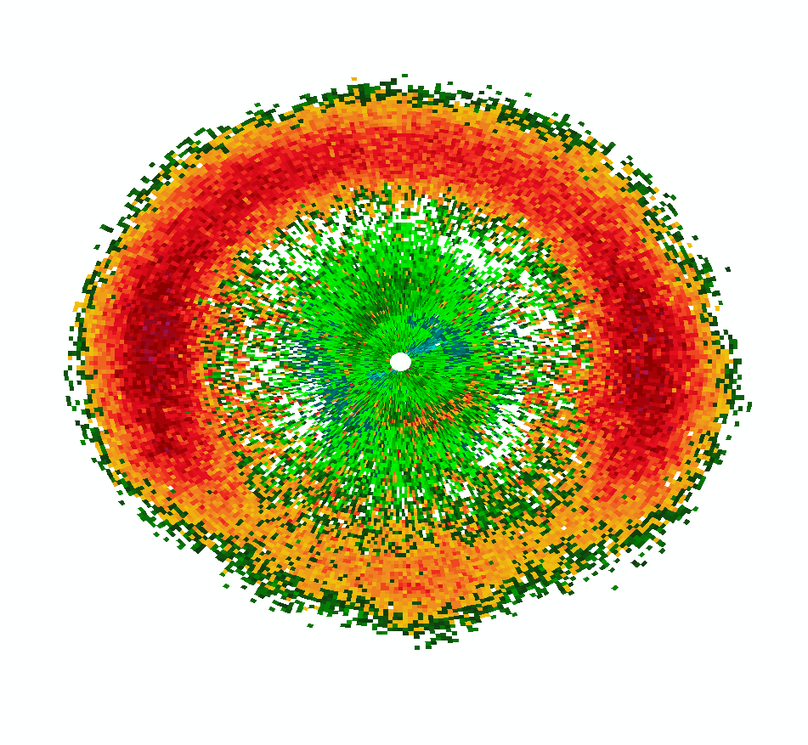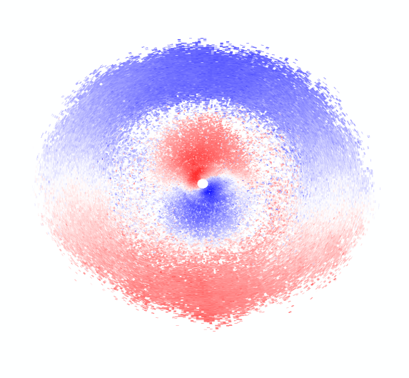
- Assume you are charged with the task of interpreting data gathered by s-band weather radar. Name 3 sources of radar echoes not including those caused by flying animals or precipitation. Are any of these more or less likely on portable x-band radar? Why or why not?

- Two nearly identical marine radars are in use for a research project. Each radar is x-band, has a maximum transmitted power of 25 kW, and the radars are being used to track targets that are around 3 km from the radar location and have an effective target area of 20 cm². Only the antennas differ. One radar is fitted with a slotted waveguide antenna that ships with the radar unit. The other radar has been fitted with a parabolic antenna. (Note: Pay attention to units as you answer the questions below.)
  - Assume the gain, quite realistically, for the slotted waveguide and parabolic antennas is 25 dB and 39 dB respectively. What is the difference in received power of these 2 radars?
  - Assuming both radars are monitoring movement of the same target. The radar with the slotted waveguide antenna is still about 3 km from the target. How far would the radar with the parabolic antenna have to be from the target to detect it with the same received power as the other radar?
  - The user of the radar with the slotted waveguide antenna is interested in increasing the effective range of her unit. She buys a new radar that transmits at twice the power of her existing one, 50 kW. All other things being equal show quantitatively whether or not she is now able to detect targets with the same received power as the 25 kW radar with the parabolic antenna.
  - What are some of the advantages and disadvantages of each kind of antenna?

- Describe 2 different portable radar setups where:
  - Data can be collected on the wing beating of targets.
  - Data can be gathered on target speed, direction, and height.

Chapter 14: Invertebrate Sampling Methods for Use in Wildlife Studies
Therese A. Catanach

- Invertebrates make up a substantial portion of Attwater's prairie chicken (Tympanuchus cupido attwateri) chicks diets. It is hypothesized that changes in fire management, agricultural practices, and introduced ant species have impacted invertebrate populations in the Gulf Coast Prairie. Identify sampling methods targeting taxa likely to be consumed by Attwater's prairie chicken chicks (i.e. Hemiptera and Orthoptera) and also methods to sample ants. Also describe potential strengths and weaknesses of the methods you identify.

- The presence of a specific invertebrate in a sampling plot does not necessarily mean this taxa has an impact on the study question. What are some characteristics of the invertebrate that must be examined?

- What is a voucher specimen and why is it important?

- Describe the following methods of long term storage and identify taxa stored in each way:
  - Slide mounting
  - Pinned
  - Point mounted
  - Fluid storage

- What is a pheromone and how can they be used in invertebrate sampling?

Chapter 15: Population Analysis in Wildlife Biology
Stephen J. Dinsmore and Douglas H. Johnson

- Contrast the theories of density dependence and density independence with respect to population growth in wildlife populations. What are the key assumptions of each theory?

- A Leslie projection matrix (L) can be used to predict future population change using the simple equation n_{t+1} = L×n_{t}. What assumptions about L are necessary to make predictions about population change using this equation?

- The Wilson’s Snipe (Gallinago delicata) is a migratory shorebird that breeds at northern latitudes in North America and over-winters from the central U.S. southward. Researchers have studied their survival and productivity and found the following results:

Age (x) S_{x} m_{x}
0 0.45 0
1 0.60 0.30
2 0.75 0.50
>3 0.80 0.75

  - Construct a Leslie projection matrix for this population.
  - If the population begins with 20 individuals of age 0, 50 individuals of age 1, 60 individuals of age 2, and 100 individuals of age 3+, how many individuals will there be a year from now?
  - What is the finite rate of population change (λ) for this population?

- $\frac{1}{N_{t}}\frac{{\text{dN}}_{t}}{\text{dt}}=r_{m}\frac{K−N_{t}}{K}$ is the equation for the per capita growth rate for logistic growth. Clearly define r_{m}, K, and N_{t}.

- Contrast the many approaches to estimate the fertility rate in wildlife populations. What are some of the problems we might encounter when estimating fertility rates? What are some advantages and disadvantages of estimating age-specific fertility rates?

- What are the differences between apparent survival and true survival? What information is required to have an estimate of true survival?

- Briefly outline the process for making valid inferences from a population model. What is a model? How are competing models considered with respect to inference about a particular question?

Chapter 16: Vegetation Sampling and Measurement
Kenneth F. Higgins, Kurt J. Jenkins, Gary K. Clambey, Daniel W. Uresk, David E. Naugle, Robert W. Klaver, Jack E. Norland, Kent C. Jensen, and WilliamTt. Barker

- Define the goals and objectives of vegetation sampling, and select and compare the sampling methodologies used in the assessment of nesting habitat for ruffed grouse vs. greater sage-grouse vs. sharp-tailed grouse. In what ways are they similar? In what ways do they differ?

- Discuss the importance of understanding the life history traits of the wildlife species under study when selecting and establishing sampling plots and transects. How does or might this affect the vegetation data being collected?

- Discuss the importance of selecting the optimal sampling plot size as a function of the habitat/vegetation being sampled when sampling to determine frequency of occurrence. How might sampling plots differ when sampling in grasslands vs. shrub-steppe vs. forested habitats?

- Determine the comparative advantages and disadvantages of the vegetation profile board, Robel pole, and staff ball methods as measures of visual obstruction (VOR). How might your choice of method be influenced by the relative size of the wildlife species for which you are measuring habitat and the habitat types in which they reside (eg. black-tailed prairie dog vs. wild turkey vs. mule deer)?

- How would you determine the production and availability of hard and soft mast in a mature eastern deciduous forest habitat?

- How does the required sample size (number of plots sampled) relate to the distribution of vegetation within the environments (randomly distributed vs. clumped distribution)? How do you determine the appropriate number of samples needed to characterize the vegetation within a specific habitat?

- The reproductive success of many grassland birds and mammals in North America has been shown to be positively correlated to precipitation during the spring months. How might you use Normalized Difference Vegetation Index (NDVI) measurements to predict reproductive efforts at the landscape level within those grasslands?

Chapter 17: Modeling Vertebrate Use of Terrestrial Resources
Lyman L. McDonald, Wallace P. Erickson, Mark S. Boyce, and J. Richard Alldredge

- Select your favorite species and discuss habitat selection at each of the scales (first-order, second-order, third-order, and fourth-order selection) according to a hierarchical scheme proposed by Johnson (1980). What factors or variables may influence habitat selection at each scale? At what scale or scales would you propose to study habitat selection for this species? What are your objectives at each scale?

- Again, for your favorite species, describe a study protocol where Design I (as defined in this chapter) would be appropriate for study of habitat or food selection. Similarly, describe a study protocol where Designs II and III would be appropriate. What are the factors that would help determine which of the designs should be selected?

- Again, for your favorite species, propose a study area where interest is in measuring habitat or food selection. Discuss the factors that influence the location and size of your study area. Give a list of potential proximate predictor variables that may influence selection of a habitat or food unit. Give a list of potential ultimate predictor variables that may influence selection of a habitat or food unit. Which of your potential predictor variables are most economical to measure? Which are most expensive to measure?

- Verify the computation of the selection ratios and standardized ratios for the Neu et al. (1974) moose track data in Table 3. Assuming the coefficients in Table 6 are correct for the RSF, , verify the computation of the values of the selection function, w(x_{i}), and standardized values in Table 7. Verify that ratios of the selection ratios in Table 3 are the same as the ratios of the values of the selection function in Table 7.

- Exercise for students who have completed a statistics course in multiple and logistic regression. Analyze the data in Table 5 using a standard logistic regression computer software program, where the dependent binary variable is Y and the independent variables are the “dummy” variables X_{i0}, X_{i1}, X_{i2}, and X_{i3}. Verify the coefficients and standard errors for the RSF in Table 6. What would be the “simulated” sample sizes for random available points if 10,000 points were assumed rather than 20,000 points? Rerun the logistic regression software with 10,000 available random points. The results should be approximately the same.

Chapter 18: Application of Spatial Technologies in Wildlife Biology
Thomas A. O’Neil, Pete Bettinger, Bruce G. Marcot, Warren B. Cohen, Oriane Taft, Richard Ash, Howard Bruner, Cory Langhoff, Jennifer A. Carlino, Vivian Hutchison, Robert E. Kennedy, and Zhiqiang Yang

- How can integrating remote sensing and GIS with risk analysis provide a way to evaluate potential threats and their costs and probabilities? Give an example of such a tool and how it could be used in resource management.
- Imagine that you will soon be using a GPS receiver to locate the positions of nest trees for an endangered bird. Describe the GPS system that you plan to use (hardware and augmentation process). Now describe your expectations of the accuracy of horizontal positions, on average, and worst-case. Discuss how subsequent spatial analyses may, or may not, be affected by the uncertainty inherent in the positions collected with the GPS receiver you are using.

- What types of quantitative models can be used to assess wildlife-habitat relationships in conjunction with geographic information systems? Select a general group of models, such as Bayesian belief network models, and through a literature search locate 5 peer-reviewed research papers using the models. Describe the manner in which they were used, the questions that were being addressed, and the limitations noted by the authors of the papers.

- Using GIS map a property of interest and list the measures that you would use to determine the site’s biodiversity? Include in your discussion how you also might address habitat functions and wildlife species at your site.

- Discuss the pros and cons of using Landsat Imagery in a landscape setting to help make more effective conservation and restoration projects.

- Using one of the above exercises, describe the metadata that is involved with the spatial and non-spatial data that is being collected.

- In certain situations, LiDAR can provide a number of advantages over traditional photogrammetric mapping and field methods, list 3–5 and develop examples in a GIS.

Chapter 19: Animal Behavior
Jessica R. Young

- What is the difference between innate and learned behaviors? Why is understanding whether a behavior of interest is innate or learned matter to the management of a species? Give 2 examples from the wildlife and conservation literature not mentioned in the chapter that support your answer.

- What is the concept of “Umwelt” and how does it help a conservation biologist consider how to best reintroduce a species into unoccupied habitat? What mistakes could be avoided if more wildlife managers understood the concept?

- How have anthropogenic activities interfered with animal’s abilities to sense their environment. Discuss 2 management strategies that could aid in species management based on an understanding of vision and smell.

- What is the difference between ultimate and proximate hypotheses? State one of each and explain how you would go about testing the hypotheses.

- How has technology changed the study of wildlife biology and conservation biology in the past 2 decades? Give examples on how technology could help gather information to test your proximate hypothesis.

Chapter 20: Analysis of Radiotelemetry Data
Joshua J. Millspaugh, Robert A. Gitzen, Jerrold L. Belant, Roland W. Kays, Barbara J. Keller, Dylan C. Kesler, Christopher T. Rota, John H. Schulz, and Catherine M. Bodinof

1. Why do you think researchers want to estimate an animal’s home range? Do the definitions of “home range” preclude inclusion of important activity areas of animals?

2. Assume you are studying home ranges of black rat snakes (Pantherophis obsoletus) in Virginia. What factors would you consider when determining which quantitative method to use to estimate home range?

3. What advantages do mechanistic models offer over other techniques when it comes to quantifying animal movements?

4. In resource selection studies, how do you determine what resources are available to an animal? Do you think it is easy to quantify resource availability? Why or why not?

5. Describe the ways that radiotelemetry helps in studies of population estimation.

Chapter 21: Reproduction and Hormones
John D. Harder

- Perhaps the one reproductive parameter of greatest importance to natality and recruitment in all vertebrates is ovulation rate. Briefly describe a measure or technique that is commonly used to estimate ovulation rate in (a) amphibians, (b) birds, and (c) mammals.

- Given a choice between birds or mammals which, for practical, technical reasons, would you choose for estimating reproductive rate? Explain.

- What is the most reliable measure of fertility or reproductive capacity in males, and how would you measure this in a live vertebrate of your choosing?

- Ovulation rate in mammals can be estimated from counts of ________________. Explain the biological basis for this estimate.

- Explain why periodic rise and fall of progesterone concentrations blood, urine, or fecal samples collected over time provide evidence of ovulatory cycles in a mammal.

- Histological examination of the ovaries of yearling does for corpora albicantia (CA) has great value and utility for estimating the percentage of fawns breeding in a population. Explain.

- Explain how fecal samples collected from a given species of herptile, bird, or mammal might be used to assess stress. Include the basics of hormone secretion and metabolism and the secretions of the hypothalamus, anterior pituitary, and adrenal cortex. Name a procedure or technique commonly used to measure hormone concentrations in blood, saliva, urine, and feces

- Explain the mechanism of action for GonaCon (a US-EPA-approved immunocontraceptive vaccine for white-tailed deer), that is based on antigens in the porcine zona pellucida (PZP).

Chapter 22: Conservation Genetics and Molecular Ecology in Wildlife Management
Sara J. Oyler-McCance and Paul L. Leberg

1. What molecular techniques exist that can be useful for wildlife biology studies? Provide examples of when each technique might be used.
2. Discuss how genetic data might be used to help assess taxonomic and management boundaries. Why are some of these methods controversial?
3. Describe the 4 processes that influence patterns of genetic diversity. How is the relative importance of these processes in changing genetic diversity likely to differ between harvested and threatened populations?
4. Many different kinds of information can be obtained from non-invasively collected genetic samples. Discuss what information needed by wildlife managers can be obtained using such samples including the strengths and weaknesses of such samples and what additional challenges such projects might face.

